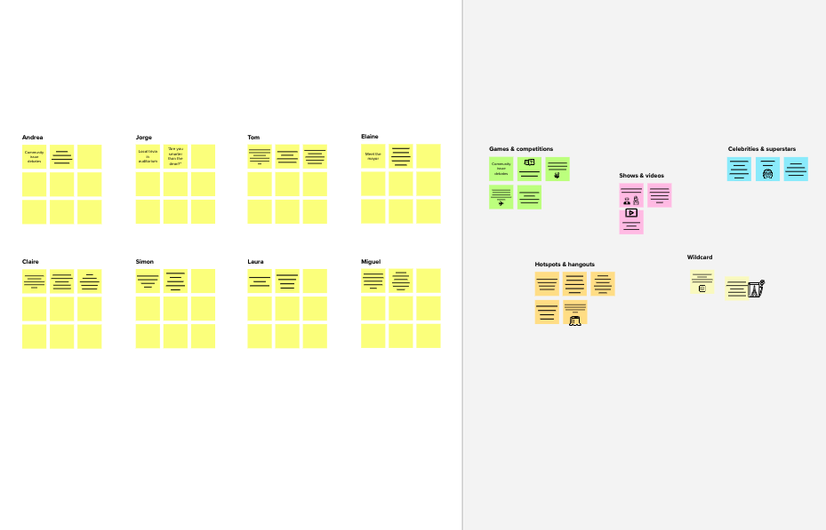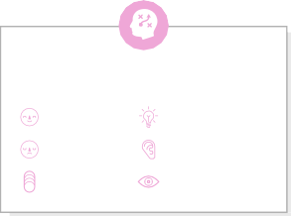

# Brainstorm

**TIP**

You can select a sticky note and hit the pencil [switch to sketch] icon to start drawing!

### Before you collaborate

A little bit of preparation goes a long way with this session. Here’s what you need to do to get going.

**10 minutes**

**1**

### Define your problem statement

What problem are you trying to solve? Frame your problem as a How Might We statement. This will be the focus of your brainstorm.

**5 minutes**

**2**

### Brainstorm

Write down any ideas that come to mind that address your problem statement.

**10 minutes**

**3**

### Group ideas

Take turns sharing your ideas while clustering similar or related notes as you go. Once all sticky notes have been grouped, give each cluster a sentence-like label. If a cluster is bigger than six sticky notes, try and see if you and break it up into smaller sub-groups.

**20 minutes**

**4**

### Prioritize

Your team should all be on the same page about what's important moving forward. Place your ideas on this grid to determine which ideas are important and which are feasible.

**20 minutes**

### After you collaborate

You can export the mural as an image or pdf to share with members of your company who might find it helpful.

**Quick add-ons**

# & idea prioritization

**PROBLEM**

The search provide over the candidate database is required to have huge set of fields to search.

**A Team gathering**

Define who should participate in the session and send an

**ch.viswanthkumar**

**TIP**

Add customizable tags to sticky notes to make it easier to find, browse, organize, and categorize important ideas as themes within your mural.

**B.ramanjaneyulu**

**The jobs and**

**g.sivakesavareddy**

**The user**

**k.upendra**

**Watching the progress of other people.**

**Analysing the personal skills.**

1. **Share the mural**

#### Use this template in your own

invite. Share relevant information or pre-work ahead.

**First I would analyse chioce user.**

**Jobs with needed salary**

**Provided or suggested only trusted jobs.**

**We should prefer a worthy job.**

**skills provided are really helpful.**

**Did not share any user information to other**

**Create the information should for when jobs are**

**available.**

**able to determine skill.**

**Getting user choice.**

**Share a view link** to the mural with stakeholders to keep them in the loop about the outcomes of the session.

#### brainstorming sessions so your team can unleash their imagination and start shaping concepts even if you're not sitting in the same room.

1. **Set the goal**

Think about the problem you'll be focusing on solving in the brainstorming session.

1. **Learn how to use the facilitation tools**

Use the Facilitation Superpowers to run a happy and productive session.

**User privacy guarded.**

**It provides confidence for the user.**

**Upgrade your job profiles.**

**Security**

Truested jobs

**User privacy guarded**

**B Export the mural**

Export a copy of the mural as a PNG or PDF to attach to emails, include in slides, or save in your drive.

**Easy way of communication between companies and users**

**10 minutes** to prepare

**1 hour** to collaborate

**2-8 people** recommended

[**Open article**](https://support.mural.co/en/articles/2113740-facilitation-superpowers)

##### Key rules of brainstorming

To run an smooth and productive session

**Username and password secured**

**Guarantee**

##### Keep moving forward

**Strategy blueprint**

Define the components of a new idea or strategy.

[**Open the template**](https://app.mural.co/template/e95f612a-f72a-4772-bc48-545aaa04e0c9/984865a6-0a96-4472-a48d-47639307b3ca)

**Customer experience journey map**

Understand customer needs, motivations, and

Stay in topic. Defer judgment.

**Suggest the course that will improve their skills**

Encourage wild ideas. Listen to others.

##### Importance

**Users able to find a job they like**

**Jobs with needed salary**

If each of these

obstacles for an experience.

[**Open the template**](https://app.mural.co/template/b7114010-3a67-4d63-a51d-6f2cedc9633f/c1b465ab-57af-4624-8faf-ebb312edc0eb)

**Collect the information about which jobs are available**

**Jobs at user preferred location**

Go for volume. If possible, be visual.

## Updates

**Expectations**

tasks could get

done without any difficulty or cost, which would have the most positive impact?

**Strengths, weaknesses, opportunities & threats**

Identify strengths, weaknesses, opportunities, and threats (SWOT) to develop a plan.

**Users able to find a job they like**

|  |  |
| --- | --- |
|  |  |
|  |  |

[**Open the template**](https://app.mural.co/template/6a062671-89ee-4b76-9409-2603d8b098be/ca270343-1d54-4952-9d8c-fbc303ffd0f2)

[**Share template feedback**](https://muralco.typeform.com/to/CiqaHVat?typeform-source=app.mural.co)

**Provide internships only at reputed company**

**First I would analyse choices user made**

**Username and password are secured**

**Jobs at user preferred location**

**Trusted jobs**

**Realtime notification of interviews**

**Vacancies are updated**

[**Share template feedback**](https://muralco.typeform.com/to/CiqaHVat?typeform-source=app.mural.co)

##### Feasibility

Regardless of their importance, which tasks are more feasible than others? (Cost, time, effort, complexity, etc.)

**Template**

###### Need some inspiration?

See a finished version of this template to kickstart your work.

[**Open example**](https://app.mural.co/template/e5a93b7b-49f2-48c9-afd7-a635d860eba6/93f1b98d-b2d2-4695-8e85-7e9c0d2fd9b9)